RESOLUTION NO.__________

RE: CERTIFICATE OF APPROPRIATENESS UNDER THE
PROVISIONS OF THE ACT OF THE PENNSYLVANIA
LEGISLATURE 1961, JUNE 13, P.L. 282 (53
SECTION 8004) AND BETHLEHEM ORDINANCE NO.
3952 AS AMENDED.

The applicant proposes to install a shed design entrance with paint colors which complement their logo colors at 81 W. Broad St.

NOW, THEREFORE, BE IT RESOLVED by the Council of the City of Bethlehem that a Certificate of Appropriateness is hereby granted for the proposal.

Sponsored by: (s)

(s)

ADOPTED BY COUNCIL THIS DAY OF

(s)
President of Council

ATTEST:

(s)
City Clerk

HISTORICAL & ARCHITECTURAL REVIEW BOARD

The applicant proposes to install a shed design entrance with paint colors which compliment their logo colors at 81 W. Broad St.

APPLICATION #4:

Domenic Villani
930 Wafford Lane
Bethlehem, PA 18018

OWNER:

__________________________________________________________________________

The Board upon motion by Phil Roeder and seconded by Beth Starbuck adopted the proposal that City Council issue a Certificate of Appropriateness for the following:

- The awning will match the existing configuration in size and profile.

2. The fabric will be black.

3. The logo will be reviewed with the Historic Officer prior to installation.

4. The vestibule will be resubmitted with additional detailed drawings for future
consideration (no action taken on vestibule)

2. The motion was unanimous to approve the awning replacement.

__________________________________________________________________________

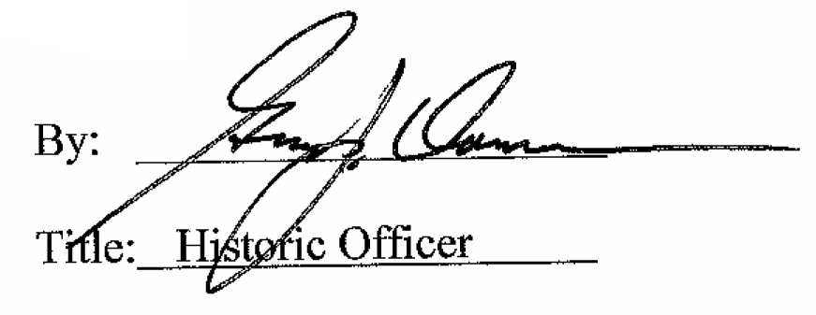

Date of Meeting: June 6, 2018

